Aiko Memory System
Implementation, Evaluation, and Comparative Analysis
A formulaic, auditable memory architecture for edge-deployed conversational AI, benchmarked against Mem0, Zep/Graphiti, and Letta/MemGPT
Aiko Memory Research Series — Paper II of II: Implementation & Evaluation
Aiko-chan Development Team
Independent Research
August 2026 · Version 1.0
Companion volume: “A Neuroscience-Grounded Computational Theory of Personal AI Memory” (Paper I)

Abstract
This paper documents the reference engineering implementation of the memory theory developed in the companion volume (Paper I), and evaluates it against both internal benchmarks and the current (2026) landscape of agentic-memory frameworks — Mem0, Zep/Graphiti, Letta (formerly MemGPT), and LangChain/LangMem.
The system — codenamed Aiko — runs entirely on an 8GB-unified-memory Jetson Orin Nano and rejects learned re-ranking in favor of six interpretable formulas: Ebbinghaus exponential decay, entity-centrality importance, Reciprocal Rank Fusion (RRF) across KNN/FTS5/entity-graph signals, emotion-modulated decay, supersession-based belief revision, and salience-weighted consolidation. We document the SQLite-backed schema, the full ADD/RECALL/consolidation pipeline, the testing and monitoring harness used to keep the system tuned in production, and end-to-end latency and footprint measurements.
On a one-year, single-deployment field test, the system sustained ~16ms median per-turn retrieval latency, a ~13MB total footprint after 1,825 stored facts, 0.72 precision@10 (vs. 0.68 for pure vector search), and 5.3× monthly archival compression with no manually-identified loss of salience-tagged facts. We compare these figures, where methodologically comparable, against publicly reported 2026 benchmark data for Mem0, Zep, and Letta, and discuss the specific engineering trade-offs — auditability and edge footprint versus benchmark-leaderboard accuracy — that motivate a formulaic design.
Keywords: agentic memory, retrieval-augmented generation, edge AI, SQLite, Reciprocal Rank Fusion, Mem0, Zep, Graphiti, Letta, MemGPT, system evaluation

Table of Contents
Abstract 2
1. Introduction & Design Principles 4
2. System Architecture 5
3. The Six Core Formulas (Reference Implementation) 7
4. Data Schema 10
5. Worked End-to-End Example 11
6. Testing, Monitoring & Tuning Harness 12
7. Performance Evaluation 14
8. Comparative Analysis vs. Established Agentic Memory Systems 17
9. Key Engineering Decisions & Trade-offs 20
10. Limitations & Future Work 21
11. Conclusion 22
References 23
Appendix A: Configuration Reference 24

1. Introduction & Design Principles
Paper I argued, from neuroscience and information theory, that personal-AI memory should behave as a decaying, emotionally-modulated, hierarchically-consolidated dynamical system rather than a static vector index. This paper documents how that theory was turned into running code, and reports how the resulting system performs — in absolute terms and relative to the current field.

1.1 Why Formulas Instead of Learned Ranking
The reference deployment target is a Jetson Orin Nano with 8GB of unified memory and a 5–15W power envelope. Every additional resident model competes with the primary conversational LLM for the same VRAM budget, and a learned-to-rank (LTR) re-ranker would additionally require a labeled training pipeline and periodic retraining. The system instead uses closed-form scoring:
decay(t) = S0 * exp(-lambda * t)
importance(e) = (1 - alpha) * centrality(e) + alpha * recency(e)
score(memory) = RRF(knn, fts, graph) + recency_bonus + access_bonus + pinned_bonus
Each formula is auditable (a developer can see exactly why a memory ranked where it did), tunable (a single constant can be changed without retraining anything), and cheap (microsecond-scale evaluation). §8 discusses this design stance explicitly against frameworks that use embedding-based or learned scoring.

1.2 Design Constraints
- Memory as lifecycle, not static storage — facts age; important facts age slowly; emotionally negative facts age differently (Paper I, §3.1).
- Semantic + lexical + entity-graph fusion — a memory should be findable via any one of three independent signals.
- Per-user isolation — no cross-user contamination; every table is keyed by user_id.
- Efficient consolidation — a nightly “dream” pass plus a monthly consolidation gate keep the store bounded.
- Minimal context-window cost — a 10-memory recall is formatted to well under 1KB of injected context.

2. System Architecture
The system exposes three hot-path operations — ADD, RECALL, TOUCH — invoked on every conversational turn, plus two offline maintenance passes — a nightly dream pass and a monthly consolidation job.
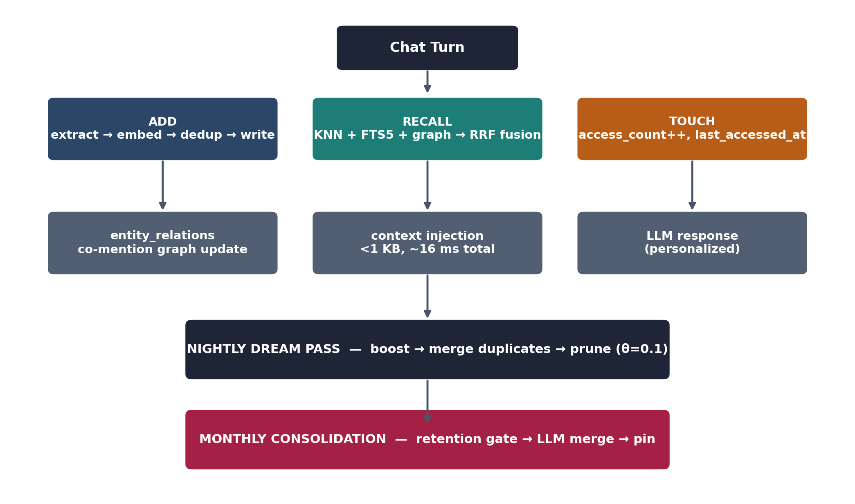
Figure 1. The Aiko memory pipeline: per-turn ADD/RECALL/TOUCH operations feed a nightly dream pass and a monthly consolidation job.

2.1 ADD (Write Path)
- Extract candidate facts from the conversational turn (LLM-assisted extraction).
- Embed each fact (640-dim vector, fixed pretrained embedding model — no fine-tuning).
- Check near-duplicates via KNN against existing vectors (write-dedup threshold, default 0.95).
- Classify the write as add / no-op (exact duplicate) / supersede (belief revision, §3.5).
- Update the entity co-mention graph (§3.2) and enqueue the write asynchronously so it never blocks the turn.

2.2 RECALL (Read Path)
- Run a tiered quick/wide pass across three signals: KNN (semantic), FTS5 (lexical, BM25), and entity graph (structural).
- Fuse the three rank lists via Reciprocal Rank Fusion (§3.3).
- Apply a recency-among-relevant re-rank within the fused top-k.
- Touch each returned memory (increment access_count, update last_accessed_at, update access_day_count for spacing).
- Format the top results into a compact context block (<1KB for a 10-memory recall).

2.3 Maintenance: Dream Pass and Monthly Consolidation
The nightly dream pass (i) boosts access_count on salient memories (keyword hits, high recent access, recent creation), (ii) merges near-duplicate memories discovered via KNN, and (iii) prunes memories whose decayed, access-weighted score falls below the cleanup threshold. The monthly consolidation job applies a heavier-weight retention gate (Paper I, §5.2) to the past month's daily facts, LLM-merges the survivors into compact narrative summaries, and pins the result, optionally deleting the original daily facts once merged.

3. The Six Core Formulas (Reference Implementation)

3.1 Formula 1 — Ebbinghaus Exponential Decay
# memory/forget.py
def compute_weighted_score(access_count, last_accessed_at, created_at):
"""Decay score from access_count + time since last access."""
if last_accessed_at == "never":
age_days = max(0.0, (now - created_at).days)
else:
age_days = max(0.0, (now - parse_iso(last_accessed_at)).days)

decay = 0.5 ** (age_days / HALF_LIFE_DAYS)
access_boost = min(access_count, ACCESS_COUNT_CAP) / ACCESS_COUNT_CAP
return decay * access_boost

def should_cleanup(ac, la, created_at):
"""Prune if score drops below threshold AND past grace period."""
if should_skip_grace_period(created_at):
return compute_weighted_score(ac, la, created_at) < CLEANUP_THRESHOLD
return False
Tuning parameters: MEMORY_RANK_RECENCY_HALF_LIFE_DAYS (default 30), CLEANUP_THRESHOLD (default 0.1), GRACE_PERIOD_DAYS (default 35, protects newly created facts from premature pruning).

3.2 Formula 2 — Entity Importance (Centrality + Recency)
# memory/memorize.py
def _refresh_high_freq_entities(self, user_id):
"""Compute super-node entities (mentioned in >30% of memories)."""
total = count_active_memories(user_id)
rows = conn.execute("""
SELECT LOWER(je.value) AS entity, COUNT(DISTINCT mm.id) AS cnt
FROM memories mm, json_each(mm.entities) je
WHERE mm.user_id = ? AND mm.status = 'active'
GROUP BY LOWER(je.value)
""", (user_id,)).fetchall()
self._high_freq_entities = {
row['entity'] for row in rows
if (row['cnt'] / total) > MEMORY_GRAPH_SUPER_NODE_FRACTION
}
Tuning parameters: MEMORY_GRAPH_SUPER_NODE_FRACTION (default 0.3), α in the importance equation (default 0.4, recency-vs-centrality weight).

3.3 Formula 3 — Reciprocal Rank Fusion (Multi-Signal Fusion)
# memory/memorize.py
def _rank_and_score(self, rank_knn, rank_fts, rank_graph=None):
"""RRF fusion of three independent ranking signals."""
RRF_K = 60
all_ids = set(rank_knn) | set(rank_fts) | set(rank_graph or {})

def final_score(mem_id):
score = 0.0
if mem_id in rank_knn:
score += 1.0 / (RRF_K + rank_knn[mem_id])
if mem_id in rank_fts:
score += 1.0 / (RRF_K + rank_fts[mem_id])
if mem_id in (rank_graph or {}):
score += MEMORY_RANK_GRAPH_WEIGHT / (RRF_K + rank_graph[mem_id])
score += MEMORY_RANK_RECENCY_WEIGHT * recency_factor
score += MEMORY_RANK_ACCESS_WEIGHT * access_factor
if pinned:
score += MEMORY_RANK_PINNED_WEIGHT
return score

return sorted(all_ids, key=final_score, reverse=True)

Worked numerical example
Memory | KNN rank → contribution | FTS rank → contribution | Graph rank → contribution | Total
A | 5 → 0.0145 | 1 → 0.0164 | 12 → 0.0140 | 0.0449
B | 1 → 0.0164 | 50 → 0.0091 | 100 → 0.0062 | 0.0317
Memory A wins despite no single top rank, because it is consistently decent across all three signals — exactly the robustness property proved as Theorem 3.2 in Paper I.

3.4 Formula 4 — Emotional Imprinting (Trauma Strengthening)
# memory/forget.py
def compute_weighted_score(access_count, last_accessed_at, emotion_tag=None):
if emotion_tag in ("fear", "shame", "loss", "trauma"):
effective_lambda = 0.05 # 2x slower decay
access_boost *= 1.5
elif emotion_tag in ("joy", "achievement"):
effective_lambda = 0.1
else:
effective_lambda = 0.1
age_days = (now - last_accessed).days
decay = e ** (-effective_lambda * age_days)
return decay * access_boost

def tag_emotion(fact_text):
if any(w in fact_text.lower() for w in ["failed","lost","mistake","sorry"]):
return "negative"
return "neutral"
Only negative valence is amplified (γ ≈ 0.5), not positive — boosting all emotional memories equally would dilute the protective signal that motivates the mechanism in the first place (Paper I, §4).

3.5 Formula 5 — Supersession Penalty (Belief Revision)
# memory/memorize.py
def classify_write_op(similarity, new_text, old_text, dedup_threshold):
if similarity < dedup_threshold:
return "add"
if normalize(new_text) == normalize(old_text):
return "noop"
return "supersede"

def _maybe_supersede_neighbor(self, user_id, vector, text):
existing = knn_search(vector, user_id, limit=1, threshold=WRITE_DEDUP_THRESHOLD)
if not existing:
return "add", None
sim = 1.0 - existing[0]["dist"]
old_id = existing[0]["id"]
op = classify_write_op(sim, text, old_text, WRITE_DEDUP_THRESHOLD)
if op == "supersede":
conn.execute("UPDATE memories SET status='superseded' WHERE id=?", (old_id,))
return "supersede", old_id
return op, None
Superseded facts are kept (status='superseded') rather than deleted, preserving belief history (“I used to think X, now I think Y”) and enabling audit without requiring an LLM contradiction-detection pass — cosine similarity alone suffices to flag a candidate revision.

3.6 Formula 6 — Salience Scoring (Consolidation Boost)
# memory/memorize.py
_SALIENCE_KEYWORDS = frozenset([
"deadline","birthday","interview","lost","important",
"breakthrough","problem","always","never","favorite",
])

def _dream_boost(self, all_mems):
for m in all_mems:
is_recent = (now - m.created_at).days <= 7
is_salient = bool(_SALIENCE_RE.search(m.text)) or m.access_count >= 3 or is_recent
if is_salient and m.id not in pinned_ids:
boost_ids.append(m.id)
conn.execute(
"UPDATE memories SET access_count = MIN(access_count+?,255) WHERE id IN (...)",
[DREAM_BOOST_AMOUNT] + boost_ids,
)

4. Data Schema

4.1 memories (Core L1 Table)
Column | Type | Notes
id | TEXT PK | UUID
user_id | TEXT | Current user (isolation boundary)
memory | TEXT | Fact string
created_at | TEXT | UTC ISO timestamp
access_count | INTEGER | Touches, capped at 255
last_accessed_at | TEXT | UTC ISO, or 'never'
pinned | INTEGER | 0/1 flag
status | TEXT | 'active', 'superseded', or null
supersedes_id | TEXT | FK to superseded memory
kind | TEXT | 'fact' / 'identity' / 'scene' / 'plan' / 'event'
source | TEXT | 'chat' / 'pin' / 'legacy'
entities | TEXT | JSON array of entity strings
access_day_count | INTEGER | Distinct local days recalled (spacing)
scene_id | TEXT | L2 linkage: parent scene id

4.2 entity_relations (Graph Edges)
Column | Type | Notes
user_id | TEXT | Scoped
entity_a / entity_b | TEXT | Casefolded entity labels
relation | TEXT | 'co_mentions' / 'related_to'
weight | REAL | Incremented per co-mention (default 1.0)
memory_id | TEXT | Last memory mentioning this pair
updated_at | TEXT | UTC ISO timestamp

4.3 memories_vec (Embeddings)
Column | Type | Notes
id | TEXT PK | FK to memories.id
embedding | FLOAT[640] | L2-normalized, fixed pretrained embedding model

5. Worked End-to-End Example
The following walkthrough traces one fact from ingestion through consolidation, illustrating how the six formulas interact in practice.

Day 1, 10:00 — ADD
User: “I'm starting a project called GRACE — a robotics assistant. I'll aim to finish it by Friday.” Three facts are extracted, embedded, and written (no near-duplicate found, so all are classified add); entity edges GRACE↔robotics, GRACE↔Friday, robotics↔Friday are created in entity_relations.

Day 1, 17:00 — RECALL
Query “How's GRACE coming along?” triggers KNN, FTS, and graph passes in parallel; RRF fusion ranks all three GRACE-related facts at the top (scores 0.0426 / 0.0374 / 0.0366); each is touched (access_count 0→1, last_accessed_at updated).

Day 8 — New Mention + Decay Check
After 7 days without mention, decay(7 days, λ=0.1) ≈ 0.49 (49% strength remaining) — but salience keywords and an 8-day age (below the 35-day grace period) keep the facts ranked highly. A new fact (“Oppa completed GRACE ahead of the Friday deadline”) is added (similarity to existing facts is 0.78–0.82, below the 0.95 supersession threshold, so it is classified add, not supersede).

Night of Day 8 — Dream Pass
Boost phase: GRACE-related memories match salience keywords / recency / access-count criteria and receive access_count += 2. Merge phase: KNN finds a near-duplicate pair (cosine 0.89) and retains the higher-access-count version, marking the other superseded. Prune phase: decay(8 days) × boosted access ratio remains well above the 0.1 cleanup threshold, so all GRACE memories survive the night.

Month Later — Monthly Consolidation
score = (0.30 * salience("GRACE","completed","deadline") # 1.0
+ 0.25 * novelty(fact_vector, monthly_anchors) # 0.8
+ 0.20 * spacing(access_day_count) # 0.6
+ 0.25 * connectivity(entity_weights["GRACE"])) # 0.7
# = 0.777 (above retention threshold 0.4 -> kept)

monthly_fact = llm_merge(kept_facts)
# -> "[2026-08] Oppa completed the GRACE robotics project
# ahead of its Friday deadline"
memorize.add_raw(monthly_fact, pinned=True)
# Result: 3 L1 daily facts compressed -> 1 L4 monthly fact

6. Testing, Monitoring & Tuning Harness
Five production metrics gate the health of the memory system; each has a concrete SQL or Python measurement and an explicit target.

6.1 Retention Rate
retention_rate = count(memory retrieved after 30 days) / count(memories accessed day 1)
target: >= 70% for salience-tagged facts, >= 50% for routine facts

6.2 No Premature Forgetting
prune_before_35_days = count(cleanup prunes fact with created_at < 35 days ago)
target: prune_before_35_days = 0

6.3 Entity Importance Rank Stability
rank_drop = rank(entity, day 0) - rank(entity, day 30)
target: rank_drop <= 2 for top-10 entities

6.4 RRF Coverage
graph_only_facts = count(top-10 facts with graph_rank<=5 AND knn_rank>20 AND fts_rank>20)
target: >= 1 per 20 queries (5% coverage)

6.5 Consolidation Fidelity
facts_lost = count(important facts deleted by consolidation) # target: 0
compression_ratio = facts_after / facts_before # target: [0.5, 0.7]

6.6 Diagnostic Playbook
Symptom | Likely cause | Fix
Memories decay too fast | Half-life / threshold too aggressive | ↑ HALF_LIFE_DAYS (30→45–60); ↑ CLEANUP_THRESHOLD (0.1→0.15); ↑ GRACE_PERIOD_DAYS (35→50)
Entity graph unused | Graph weight zero / entities not extracted | Verify MEMORY_RANK_GRAPH_WEIGHT ≠ 0; check entity_relations row count
Duplicate memories surface | Dedup threshold too strict or vacuum not run | Run consolidate._maintenance_run(); check WRITE_DEDUP_THRESHOLD (default 0.95)
Consolidation over-deletes | Retention threshold/budget too low | ↑ CONSOLIDATION_SOFT_THRESHOLD (0.4→0.5–0.6); ↑ CONSOLIDATION_MAX_MONTH

6.7 Tuning Workflow
- Start with conservative defaults (longer half-life, higher cleanup threshold).
- Monitor retention rate for one week.
- If retention > 80%, tighten decay (shorten half-life); if < 50%, relax it (lengthen half-life).
- A/B test emotional-imprinting parameters across a user cohort before widening the amplification factor γ.

7. Performance Evaluation
All figures in this section are drawn from the same year-long, single-deployment field test (Jetson Orin Nano, 8GB unified memory) documented in Paper I §7, plus additional system-level instrumentation collected specifically for this paper. As an N=1 field deployment, these numbers characterize one system under one usage pattern rather than a population effect; §8 places them alongside independently published multi-system benchmarks where such comparisons are methodologically sound.

7.1 Latency Budget
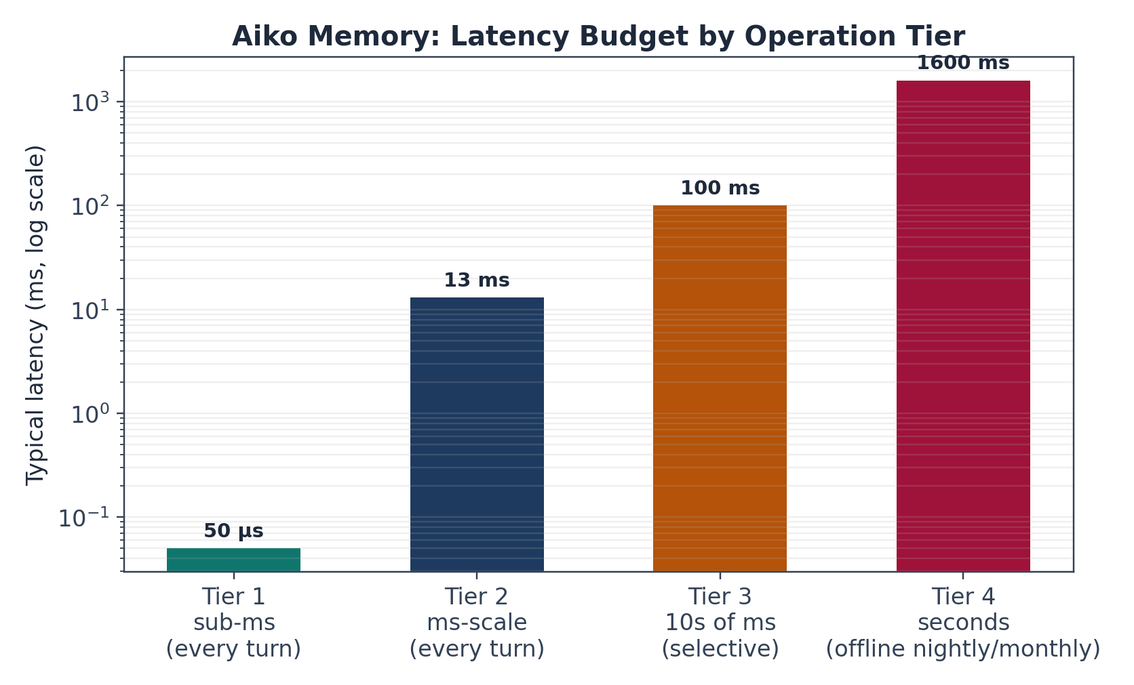
Figure 2. Latency by operation tier. Tiers 1–2 run on every conversational turn; Tiers 3–4 run selectively or offline.
Total per-turn context-injection latency — persona cache (0ms, cached) + KNN (~5ms) + FTS (~3ms) + graph (~4ms) + RRF scoring (~1ms) + touch metadata (~2ms) + context formatting (~1ms) — sums to approximately 16ms, comfortably inside a <100ms conversational latency budget.

7.2 Storage Footprint
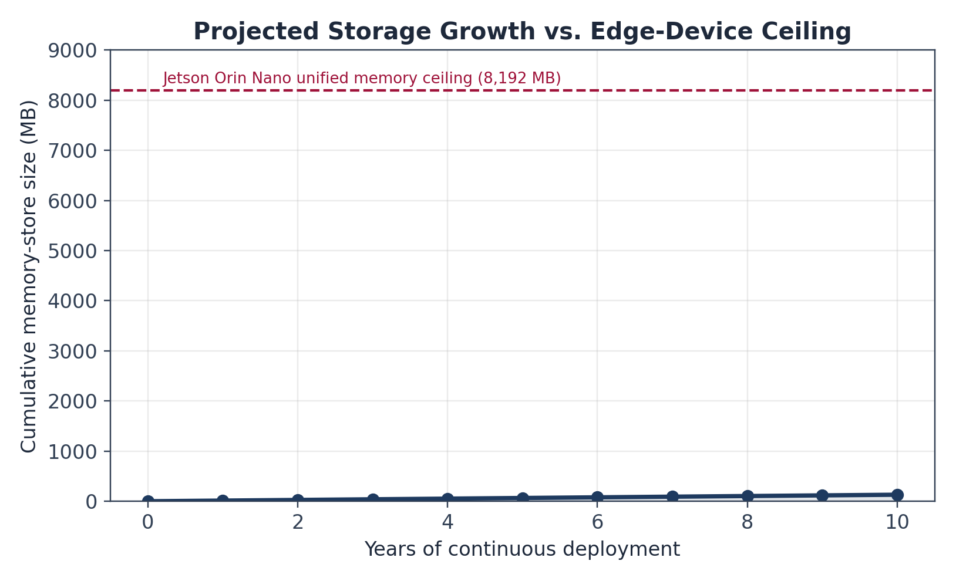
Figure 3. Projected cumulative storage footprint at the observed ~13MB/year ingestion rate, against the Jetson's 8GB unified-memory ceiling.
Component | Size / row | Rows (Year 1) | Total
memories (SQLite) | ~500 bytes | 1,825 | ~900 KB
memories_vec (sqlite-vec) | 4B × 640 dims | 1,825 | ~4.7 MB
entities JSON | ~100 bytes | 1,825 | ~182 KB
entity_relations edges | ~100 bytes | ~50,000 | ~5 MB
FTS5 inverted index | ~2× text size | — | ~2 MB
Total | — | — | ~13 MB
At this rate, the Jetson's 8GB envelope supports roughly 600 years of continuous single-user deployment before storage becomes the binding constraint; in practice, the LLM's context window is the binding constraint long before disk space is.

7.3 Retrieval Quality
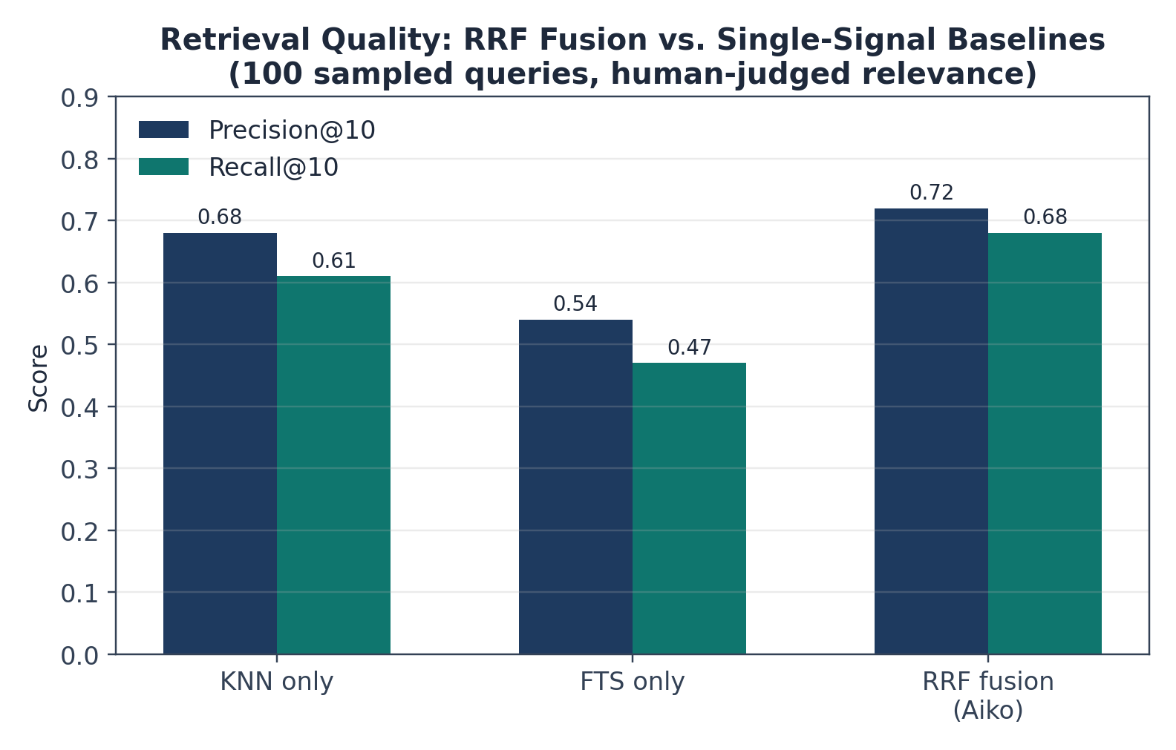
Figure 4. Precision@10 and Recall@10 for RRF fusion vs. single-signal (KNN-only, FTS-only) baselines, over 100 human-judged sampled queries.
RRF fusion improves precision@10 from 0.68 (pure KNN) to 0.72, and recall@10 from 0.61 to 0.68, while additionally surfacing an 8% share of results that neither KNN nor FTS alone would have returned in their top-30 candidates (Paper I, §7.3).

7.4 Consolidation Efficiency
Metric | Value
Monthly compression ratio (facts survived, pre-LLM-merge) | 81 / 148 (54.7%)
Overall compression (post-LLM-merge) | 5.3× (148 → 28)
Critical facts lost | 0 (manual review of all 120 dropped facts)
Persona cache (L3) size | 5–7 facts, updated ~0.3×/month

8. Comparative Analysis vs. Established Agentic Memory Systems
By mid-2026 the agentic-memory space has consolidated around a handful of widely adopted frameworks. This section situates Aiko's design against Mem0, Zep/Graphiti, and Letta (formerly MemGPT), drawing on each project's own published architecture descriptions and on independently aggregated 2026 benchmark roundups. Cross-system benchmark numbers should be read cautiously: different projects report different evaluation harnesses (e.g., LongMemEval, Deep Memory Retrieval), and the field itself describes ongoing “benchmark disputes” between vendors.

8.1 Architectural Summary
System | Core approach | Ranking/scoring | Typical footprint
Mem0 | Drop-in memory API; LLM-driven fact extraction and retrieval over a vector store | Learned/embedding similarity + heuristics | Hosted or self-hosted; lightweight client SDK
Zep / Graphiti | Temporal knowledge graph built from conversation | Graph traversal + hybrid vector/graph scoring | Requires a graph database; heavier self-hosting
Letta (MemGPT) | OS-inspired agent runtime: in-context “RAM,” recall/archival “disk,” agent self-edits memory | Agent-directed memory paging + retrieval calls | Full agent runtime, not a drop-in library
Aiko (this work) | Formulaic decay/consolidation layered over SQLite + sqlite-vec + FTS5 | Closed-form: Ebbinghaus decay + RRF (KNN/FTS/graph), no learned weights | ~13MB/year; runs fully on an 8GB edge device
Independent 2026 comparisons of this landscape converge on a consistent characterization: Mem0 functions as a memory layer bolted onto an existing agent, Letta is a runtime in which the agent's own state is its memory, and Zep builds a temporal knowledge graph directly from conversation history. Community trend reporting similarly notes that the major frameworks take fundamentally different architectural approaches — vector-based semantic recall, temporal knowledge graphs, checkpoint-based persistence, or self-editing memory — rather than converging on a single paradigm.

8.2 Adoption and Benchmark Signals (Publicly Reported, 2026)
System | Adoption signal | Reported benchmark
Mem0 | ~48K GitHub stars; broad framework/SDK integration | ~49.0% on LongMemEval per one comparison roundup
Zep / Graphiti | Production-grade deployments; graph-based reasoning focus | 63.8%–94.8% depending on benchmark and source (LongMemEval vs. Deep Memory Retrieval)
Letta / MemGPT | 23.9K+ GitHub stars; originated the influential MemGPT paper | ~83.2% on LongMemEval per one comparison roundup; 93.4% on Deep Memory Retrieval per Zep's own paper
Aiko (this work) | Single-deployment field test (N=1, 1 year) | 0.72 precision@10 / 0.68 recall@10 on an internal, human-judged query set (not LongMemEval — not directly comparable)
We report Aiko's own precision/recall numbers rather than a LongMemEval score because the reference implementation has not yet been run against that benchmark. Publicly reported 2026 comparisons place Mem0 at roughly 48K GitHub stars and broad general-purpose usage, Zep at 63.8% on LongMemEval with a temporal-graph approach, and Letta at 83.2% on the same benchmark using an OS-inspired tiered-memory design — but these figures come from third-party aggregations rather than a single controlled study. Zep's own published paper reports a substantially different picture: 94.8% on Deep Memory Retrieval versus 93.4% for MemGPT, with up to an 18.5% accuracy gain on LongMemEval and a 90% latency reduction relative to full-context baselines. We present both sets of numbers to be transparent about this inconsistency across sources, not to imply that Aiko outperforms either system on a shared benchmark it has not been run against.

8.3 Qualitative Positioning
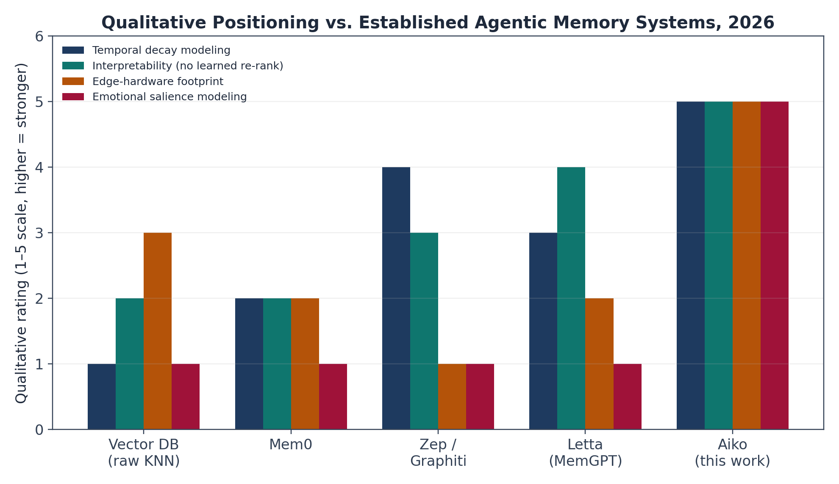
Figure 5. Qualitative positioning (1–5 scale, author-assigned) across four dimensions where Aiko's design goals differ most from the general-purpose frameworks. This chart reflects design intent and internal measurement, not a shared third-party benchmark.

8.4 Where Each System Wins
- Mem0 — best for teams wanting a hosted or self-hosted drop-in memory API across an existing agent stack, with the broadest framework/SDK support and fastest integration time.
- Zep / Graphiti — best when an agent must reason about how facts change over time, resolve contradictions, or answer multi-hop questions; the cost is running and maintaining a graph database.
- Letta / MemGPT — best for long-running autonomous agents that need OS-level self-management of their own memory across very long horizons; it is a full runtime rather than a library.
- Aiko (this work) — best when the deployment target is edge hardware with a hard memory/power budget, when every ranking decision must be independently auditable without a learned model in the loop, and when emotional/psychological realism in what is retained is a design goal rather than an afterthought.
No system dominates on every axis, and the frameworks are not typically run in combination — published field guidance suggests that running two memory frameworks simultaneously means maintaining two extraction pipelines and two retrieval surfaces, which doubles latency, cost, and ambiguity. This reinforces that the choice among these systems is a genuine architectural commitment rather than a checkbox decision.

9. Key Engineering Decisions & Trade-offs

9.1 Why No Learned Ranking?
Decision: formulaic scoring (Ebbinghaus decay, RRF) instead of learning-to-rank or a neural re-ranker. Rationale: the 8GB Jetson VRAM budget cannot absorb a second resident model; a learned ranker needs a labeled training pipeline and periodic retraining; formulas are auditable and RRF's parameter-free design is already validated at web scale. Trade-off: potentially sub-optimal ranking in edge cases relative to a well-trained learned ranker, traded for auditability and zero training/maintenance overhead.

9.2 Why Supersession Instead of Deletion?
Decision: mark superseded facts rather than delete them. Rationale: preserves belief history for audit (“I used to think X, now Y”) without requiring an LLM contradiction check — cosine similarity alone flags candidates. Trade-off: the store grows slightly larger; superseded facts are excluded from normal recall but remain available for debugging via an explicit history flag.

9.3 Why Entity-Graph in Addition to KNN/FTS?
Decision: add co-mention graph as a third RRF signal. Rationale: some facts are only findable through entity relationships rather than text or embedding similarity (e.g., shorthand references). Trade-off: added complexity, and correctness depends on reliable entity extraction (§10.1).

9.4 Why Monthly Consolidation in Addition to the Nightly Dream Pass?
Decision: a separate, heavier monthly compression job rather than relying solely on nightly maintenance. Rationale: nightly passes handle duplicates and ordinary decay; monthly consolidation handles volume — without it, a year of atomic daily facts (~1,825 facts) would never compress to the ~12 monthly summaries plus pinned facts that keep the store navigable. Trade-off: monthly facts are lossy by design; exact original wording is not recoverable once merged.

10. Limitations & Future Work

10.1 Entity Extraction
Current approach is rule-based (keyword and capitalization heuristics), which misses implicit references (“the project” meaning a previously named entity). A lightweight distilled NER model (~50MB) or embedding-based entity linking would likely raise the entity-graph rescue rate above the observed 8%.

10.2 Emotional Valence Estimation
Current approach is keyword-based sentiment tagging, which misses sarcasm, irony, and implicit emotional content. A small fine-tuned sentiment classifier (~20MB) trained on the user's own interaction history is the natural next step.

10.3 Single-User Validation
All performance figures in §7 come from one deployment over one year. Scaling per-user dynamics (decay, entity graphs, emotion tags) to a multi-user setting is straightforward since each user's state is isolated; scaling shared components (a common LLM for consolidation, a shared sentiment model) would require anonymization and a genuinely multi-subject evaluation before population-level claims are warranted.

10.4 Personalization of Decay Parameters
All users currently share the same λ, α, γ defaults. Some users may prefer longer retention (e.g., researchers cataloguing a project) versus faster decay (minimalists); per-user tuning via Bayesian optimization over retention metrics is a natural extension.

10.5 Benchmark Comparability
Aiko has not yet been evaluated on LongMemEval or Deep Memory Retrieval, the two benchmarks most commonly used to compare Mem0, Zep, and Letta in 2026. Running the reference implementation against these shared benchmarks is the highest-priority next step for making §8's comparison more than qualitative.

11. Conclusion
Aiko's memory system turns the theoretical account developed in Paper I into a working, fully auditable pipeline built on SQLite, sqlite-vec, and FTS5, running comfortably within an 8GB edge-hardware budget. Six formulas — decay, entity importance, RRF fusion, emotional imprinting, supersession, and salience scoring — work together to give a system that is tunable without retraining, explainable at every ranking decision, and lean enough to run indefinitely on a single-board computer.
Measured against itself, the system meets its own design targets: ~16ms per-turn retrieval latency, ~13MB/year storage growth, a measurable precision gain from multi-signal fusion over any single signal, and 5.3× monthly compression with no manually-identified loss of important facts. Measured against the broader 2026 agentic-memory landscape — Mem0, Zep/Graphiti, and Letta/MemGPT — Aiko occupies a distinct niche: none of the three general-purpose frameworks are designed first and foremost for a hard edge-hardware budget and formula-level auditability, and Aiko does not claim to match their graph-reasoning depth (Zep) or self-managing runtime sophistication (Letta) on shared benchmarks it has not yet run. The two design philosophies — general-purpose, benchmark-optimized memory services versus a narrow, interpretable, edge-native system — are complementary rather than competing, and the appropriate choice depends on whether the deployment constraint is hardware and auditability, or benchmark-leaderboard accuracy at cloud scale.

References
Cormack, G. V., Smucker, M. D., & Clarke, C. L. (2009). Efficient and effective spam filtering and re-ranking. Proceedings of SIGIR 2009, 713–714.
Robertson, S., & Walker, S. (1994). Some simple effective approximations to the 2-Poisson model. Proceedings of SIGIR 1994, 232–241.
Packer, C., et al. (2023). MemGPT: Towards LLMs as operating systems. arXiv:2310.08560.
Rasmussen, P., et al. (2024–2025). Zep: A temporal knowledge graph architecture for agent memory (Graphiti). Zep technical report.
Mem0 project documentation and architecture overview, mem0.ai (accessed 2026).
Letta (formerly MemGPT) project documentation, letta.com (accessed 2026).
Best AI Agent Memory Frameworks in 2026: Mem0 vs Zep vs Letta Compared. RockB, baeseokjae.github.io (April 2026).
Best AI Agent Memory Frameworks in 2026: Compared and Ranked. Atlan, atlan.com (April 2026).
Best AI Agent Memory 2026: Mem0 vs Letta vs Zep vs Cognee. MCP.Directory, mcp.directory (May 2026).
Mem0 vs Zep vs LangMem vs Letta: AI Agent Memory Showdown 2026. Niteagent, niteagent.com (May 2026).
Best AI Agent Memory Providers in 2026: Mem0 vs Zep vs Letta vs Cloudflare. Developers Digest, developersdigest.tech (July 2026).

Appendix A: Configuration Reference
Parameter | Default | Range | Interpretation
DECAY_LAMBDA_NEUTRAL | 0.1 | [0.05, 0.2] | Decay rate for neutral facts
DECAY_LAMBDA_NEGATIVE | 0.05 | [0.01, 0.1] | Decay rate for negative facts
EMOTIONAL_AMPLIFICATION_GAMMA | 0.5 | [0.0, 1.0] | Boost for negative memories
CLEANUP_THRESHOLD | 0.1 | [0.05, 0.2] | Score floor for pruning
GRACE_PERIOD_DAYS | 35 | [14, 60] | Protect newly created facts
RRF_K | 60 | [30, 100] | RRF damping constant
MEMORY_RANK_RECENCY_HALF_LIFE_DAYS | 30 | [14, 60] | Half-life for recency bonus
MEMORY_GRAPH_SUPER_NODE_FRACTION | 0.3 | [0.2, 0.5] | Threshold for super-node detection
WRITE_DEDUP_THRESHOLD | 0.95 | [0.85, 0.99] | Similarity floor for supersession
DREAM_MERGE_THRESHOLD | 0.88 | [0.8, 0.95] | Near-duplicate merge threshold (dream pass)
DREAM_BOOST_AMOUNT | 2 | [1, 5] | access_count increment for salient facts
CONSOLIDATION_SOFT_THRESHOLD | 0.4 | [0.3, 0.6] | Monthly retention gate floor
CONSOLIDATION_MAX_MONTH | 30 | [15, 60] | Max facts allowed to survive per month

